Laboratory 2 Extra Credit Problem ( up to 1.5 points )

SPATIAL ANALYSIS WITH IMAGES

Extra Credit Report Due Date: Same date as Lab 2 Report.

Conditions to Receive Credit: All analysis, Matlab programming/plotting, and report writing must be your own original effort to receive points on this extra credit problem. Any verbatim reports or strongly similar reports and listings will receive 0 extra credit. The grade from 0 to 1.5 points will be determined by the level of effort reflected in the report and the originality and correct use of spatial analysis expressed in the report.

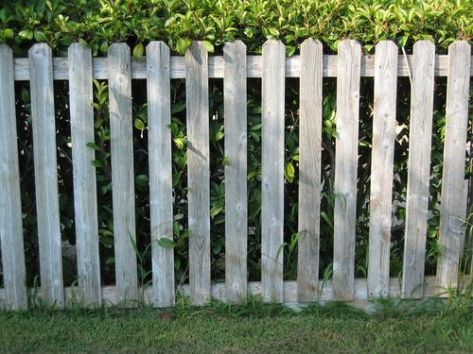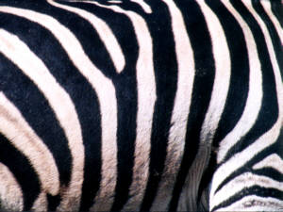
Figure EC-1. Color photos of picket fence and two different zebras for use with the extra credit problem.

1. Introduction

In Tasks 4.1 and 5.1, you learned the meaning of spatial frequency and used a variation of the discrete-time Fourier transform, computed with an FFT in Matlab, to generate estimates from pixel rows of a USB camera-acquired image, consisting of sequences of structured rows with periodic patterns. For this extra credit problem, you will apply the same spatial frequency analysis principles to spatially analyze actual color camera images of objects with primarily horizontal (one-dimensional) periodic or nearly periodic patterns. These are shown in Figure EC-1, and may be found as JPEG-formatted compressed files on the class Lab web page as picket_fence3.jpg, zebra_stripes1.jpg, and zebra_stripes3.jpg, which have been calibrated with pixel spacings of ¼-in/pixel, 1/2-in/pixel, and 1/8-in/pixel, respectively . You will need to use Matlab function imread to read these files into the Matlab environment.

2. Analysis Tasks

2.1 Convert all color images to gray-scale images with rgb2gray .

2.2 Perform row-by-row spatial frequency analysis from the gray-scale image. Consider how much zero-padding to use to get a smooth plot, and also consider use of window weighting such as Hamming (page 639) to reduce sidelobe artifacts. Investigate 3-D plotting routines available in Matlab to plot a 3-D display of spatial frequency vs row number vs transform magnitude in order to visualize the spatial frequency variation with row number.

2.3 Plot the spatial spectrum of selected rows from each of the 3 images that have interesting spatial frequency patterns that can be related, in your estimation, to physical periodic features in the image.

2.4 Generate an average spatial spectrum plot. Accomplish this by summing, at each frequency point in the transform you used in Task 2.2, the spectral values across all rows (and then divide by the number of rows to get the average at that frequency point).

3. Report Contents

Besides reporting and plotting the analysis of Section 2, also provide answers to the following.

Picket Fence. Can you see a harmonic spectrum (multiple peaks at uniform spatial frequency spacings) due to the periodic picket fence structure? Based on the relative amplitudes of the harmonics, can you infer from the spatial frequencies the picket spacings (periodicity) and the width of the slats relative to this spacing (duty cycle)? Can you tell which rows of the photo the picket fence is in and what rows it is not in by looking only at the row-by-row spatial analysis?

Zebra Stripes. We would like to employ spatial spectral analysis to develop automated pattern recognition software that is able to distinguish individual zebras based on the spatial frequency content from photos. Pattern recognition of imagery often uses two-dimensional Fourier transform analysis, but we will limit ourselves here to just one-dimensional horizontal analysis. Can you distinguish the zebras based on differences in the average spatial spectrum plots generated for Task 2.4? Are there individual line rows in the images that, by themselves, distinguish the zebras? Based on your observations, suggest a pattern recognition algorithm flowchart, with a foundation based in spatial frequency analysis, which would automatically distinguish zebras based on their stripe patterns.

